**EDS THEORY Assignment 1**



**Name :** Nikhil Jatale  
 **PRN :** 202401120023  
 **Class :** CS8  
 **Roll No :** 59

DATASET LINK :- AMAZON PRODUCT DATASET(<https://www.kaggle.com/datasets/lokeshparab/amazon-products-dataset>)

**Problem statements:-**

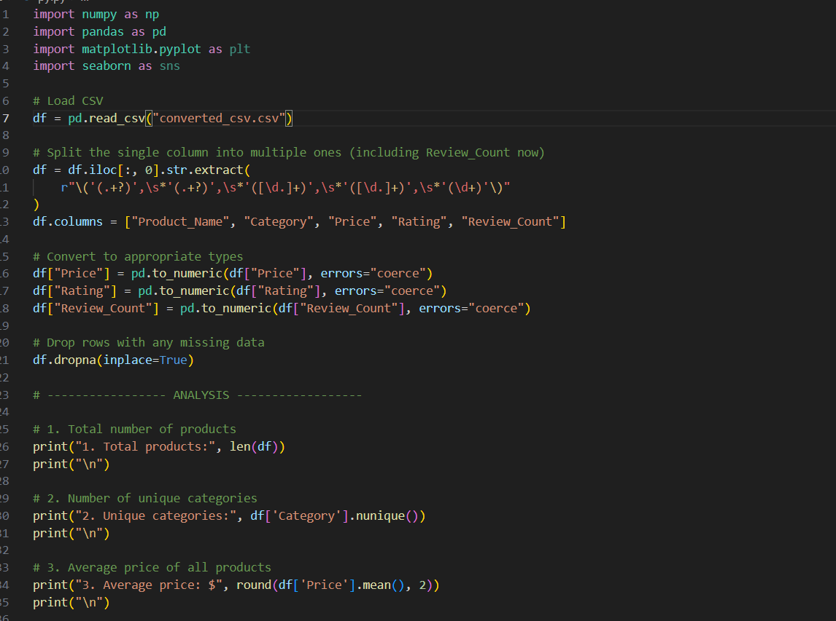

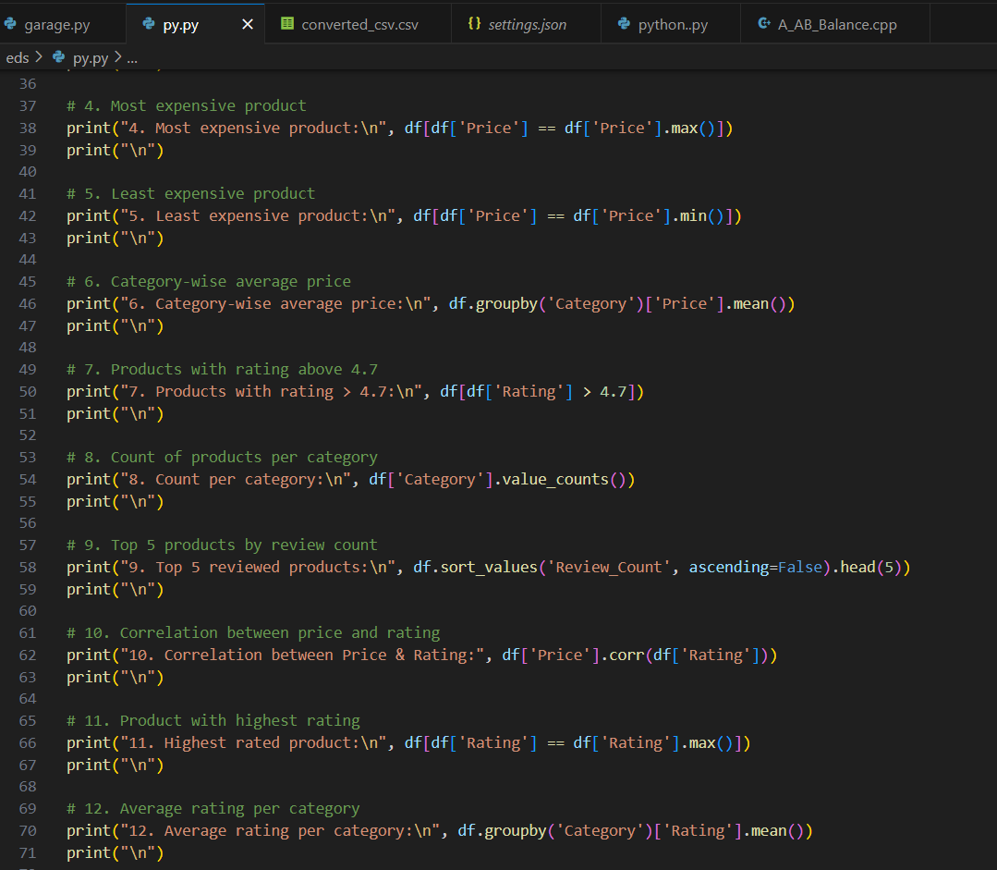

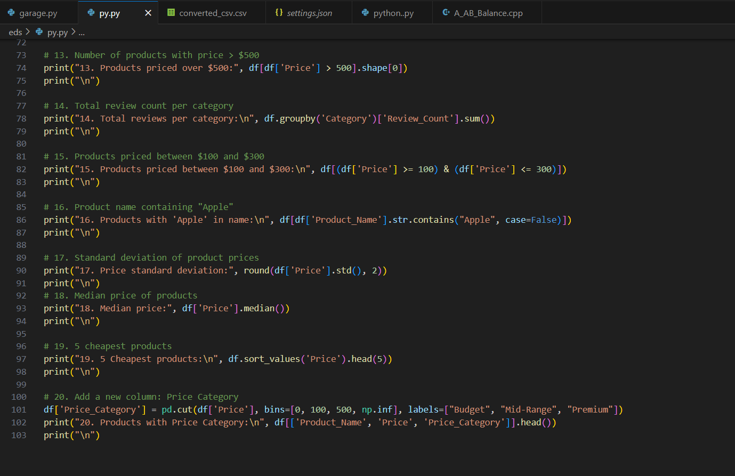

**Solution:-**

